**Applied Statistics - Lab 4**

**Date of performance:** 09-09-2021

**Date of Submission:** 16-09-2021

**SAP Id:** 500083382

**Name:** Anurag Singh

**Batch:** AI&ML B2

**___________________________________________________________________________**

**Topic: Normal Distribution and Z Distribution**

**Problem:**

Create a dataset of a single variable comprising only numerical values. Create a Normal distribution for it. Convert it to Z distribution and plot both of the distribution

**Creating a dataset for Normal distribution**

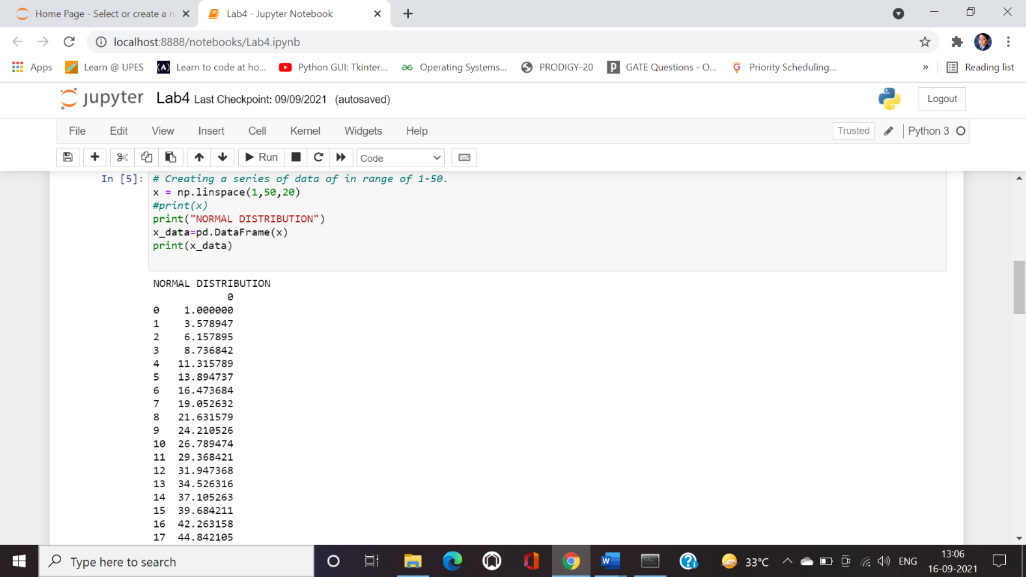

**Deriving the dataset for Z distribution from the dataset of Normal distribution**

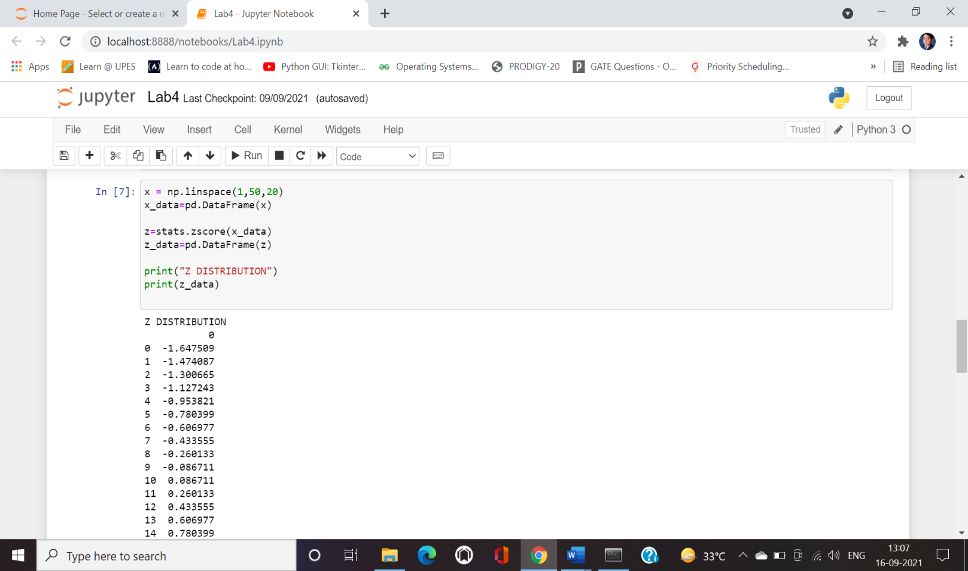

**Plot for Normal Distribution data**

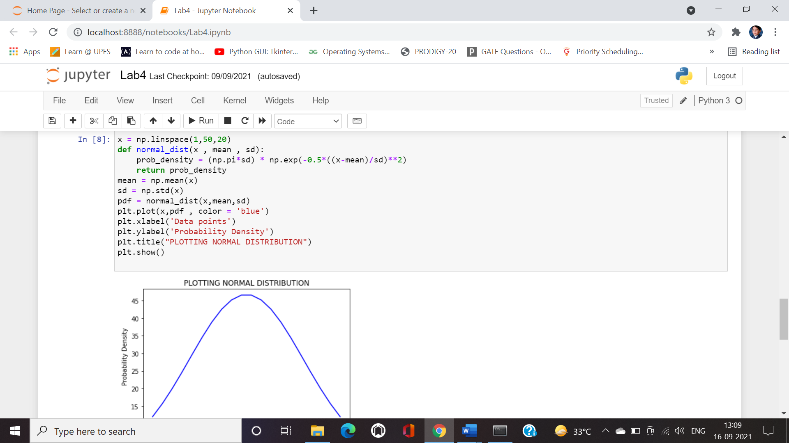

**Plot for Z Distribution data**

